Transmission jack 500kg REDATS H-220
- Hydraulic jack with a foot pump. The jack can be used for lifting gearboxes, engines or suspension parts. The max. capacity is 500 kg.
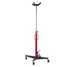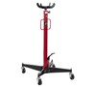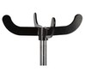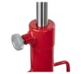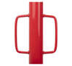+5pictures
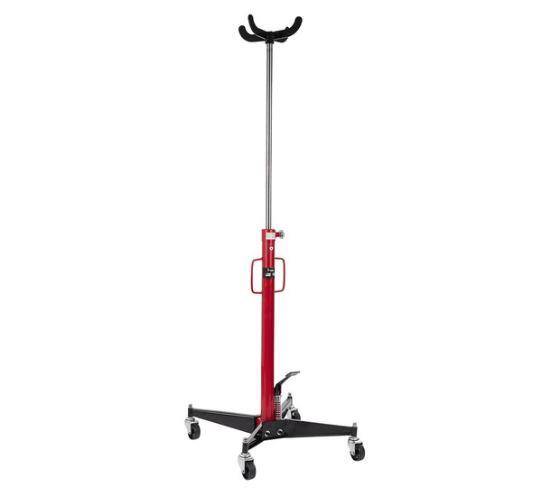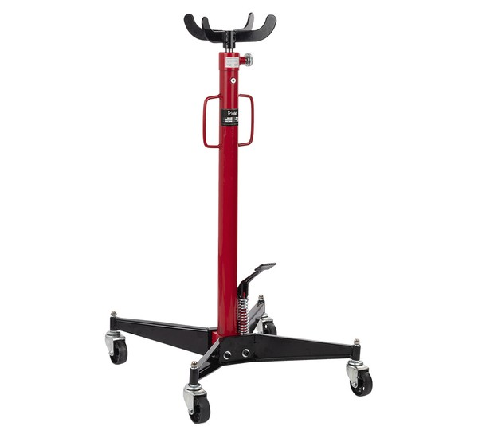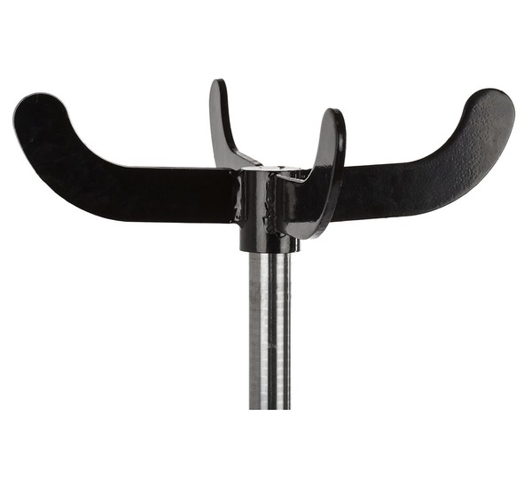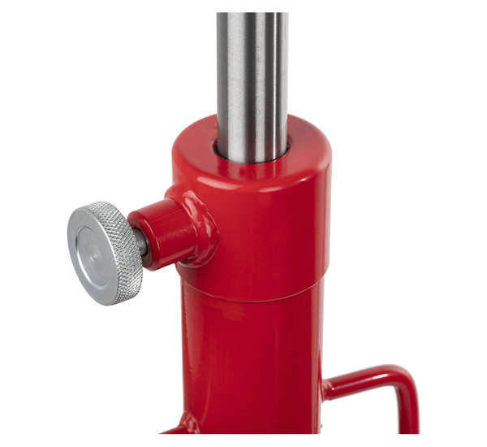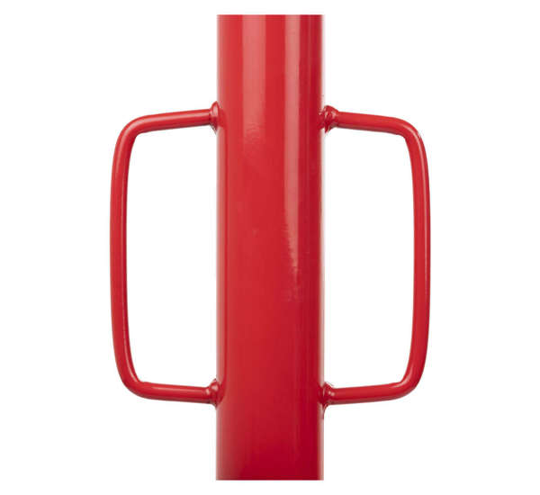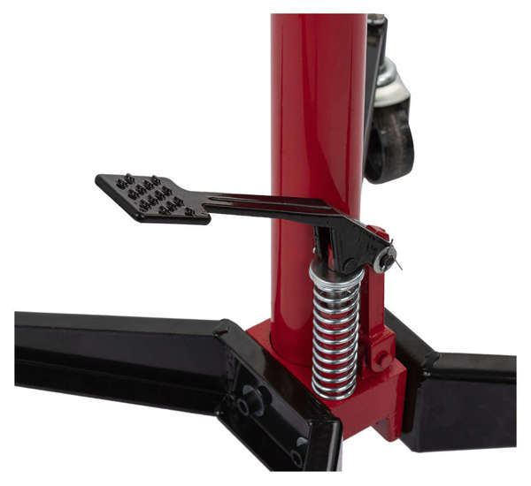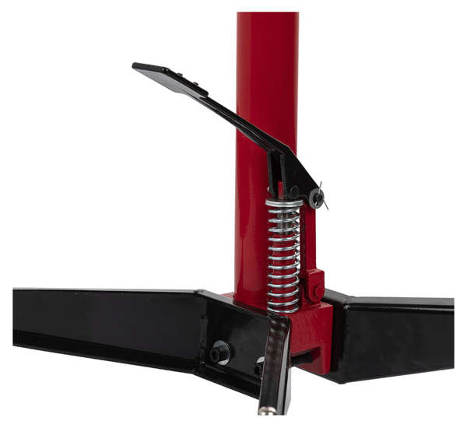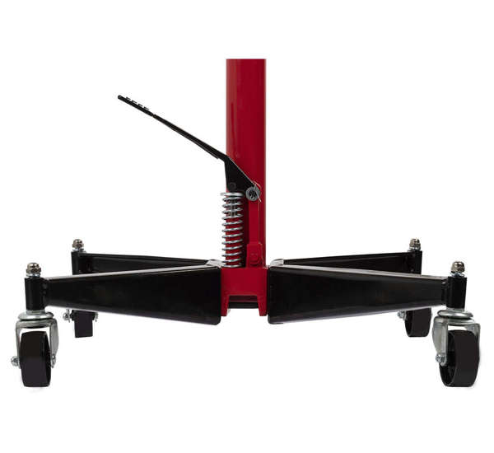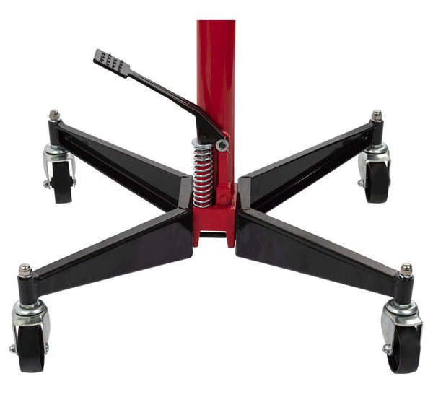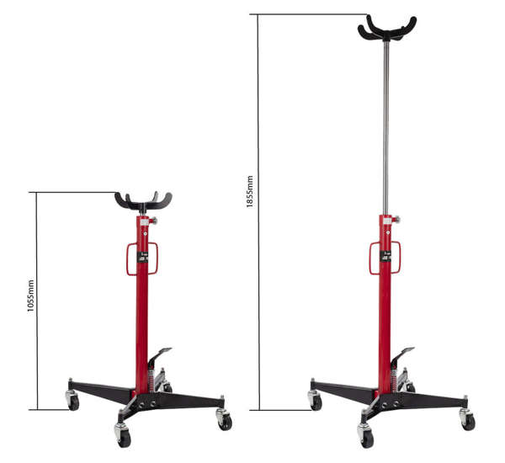

479 pcsVery high stock
Ready for dispatch
in 10h
Check delivery time and costs
71,88 €
62,00 €
/ pc net
You save 14% (9,88 €).
Add to basketAdd to shopping listCompare
Find out in which store you can check the product and buy it right away

Application
This jack is a great addition for lifting gearboxes, engine or its parts.
Exceptional quality
The lift is based on reliable metal parts, as well as welds. This means long and trouble-free operation for many years. You don't have to worry about instability or troubles related to lifting certain elements.
Comfortable moving
We designed this jack with your comfort in mind. 4 large castors (diameter: 7 cm) make moving around the jack much easier.
Foot pedal - easier operation
The load is lifted upon the pressing of a foot pedal. To lower it, just release the knob located at your fingertips.
Working range
You can set the jack in any position between 1055 and 1855 mm (working range: 800 mm). This means, you can easily adjust the lift to any car.
Adjustable adaptor - an extra option
You can also get an adjustable adaptor (capacity of 500kg) for this gearbox lift. It can be adjusted in 2 surfaces: high-low or left-right.
Producer
REDATS
Product code
07-01-82
Manufacturer
REDATS
maximal capacity
500 kg
Working scope
1055 -1855 mm
Base dimensions (with castors)
590 x 610 mm
Weight
24,5 kg
Set includes
handle 320 mm

RECOMMENDED PRODUCTS

